Git -> code history track & maintain

Suppose you make a project that is related to ecommerce website clone for the uni project & you have a team & you have completed this project & when you went for the submission evaluator asked to you how many lines of code your team wrote…
Frnd 1 -> write code 3000 lines
Frnd 2 -> write code 1000 lines
How to track?

You develop a whole website that includes
Header
Body
Footer
Suppose you code for the header then git commit/changes & take snapshot/ screenshot of your code
Same like this for body & footer as well
After that you have to write code for the payment gateway you write multiple lines of code but you code didn’t execute
& you have to go for the last commit so you can wrote only one cmd & its done

Github -> share code to others or centralized database
Suppose you have to share the code to all students will you share individually to every student or you will keep the code on 1 place & tell everyone to access from there

Suppose you are working for the amazon there are 10000 employees who write code so if you make changes on that code first you will do it on your pc then share on github so that all can see

Engagement -> weeding
Add -> commit

Git -> Github

Readme.md -> markdown
Commit means take sc & save it to memory

When we commit so we give name that is sc name

Basic html is required to change the readme file

Git –version
Ls -> all files
Pwd -> our working directory
Clear

Configuring git
Git config –global user.name “my name”
Git config –global user.email “someone@email.com”
Git config –list (git config se hm ne kya setup kyah)

Global local
All repo specific repo

~ -> we are in the root directory/folder of the system
Coding process with git process

So we use vs code

Coding process ko git process k sth rkhte h

Clone & status
Clone -> cloning a repository on our local machine
Git clone link
Status -> displays the state of the code
Git status

Remote local
[github] [laptop/pc]

Cd -> change directory such as you have to go to the parent folder
Cd then folder name
Ls -> means list files if you want to see all files so you can use this
There are also some hidden files to check so for this just type
Ls -a
So you can see all hidden files

If we modify any file there will be 2 steps
Add & commit
If we create any new file so it will be untracked file

There are four types of git status
Untracked -> new files that git doesn’t yet track
Modified -> changed
Staged -> file is ready to be committed
Unmodified -> unchanged

Change newfile
Modified untracked
Add (staged)
Commit (unchanged)

Add & commit
Add -> adds new or changed file in your working directory to the git staging area
Git add file name

Commit -> it is record of change
Git commit -m some message

Add commit
Engagement wedding
Stage

If we add to all files so we just write
Git add .

Git commit -m “fix old bugs”
Git commit -m “add new features”
Git commit -m “add new heading”

You branch is ahead of ‘origin/main’ -> means that local system one commit greater than remote repository
So in this way our local changes will not show in remote
So for this we have to just type one cmd that is

Push cmd
Push -> upload local repo content to remote repo
Git push origin main

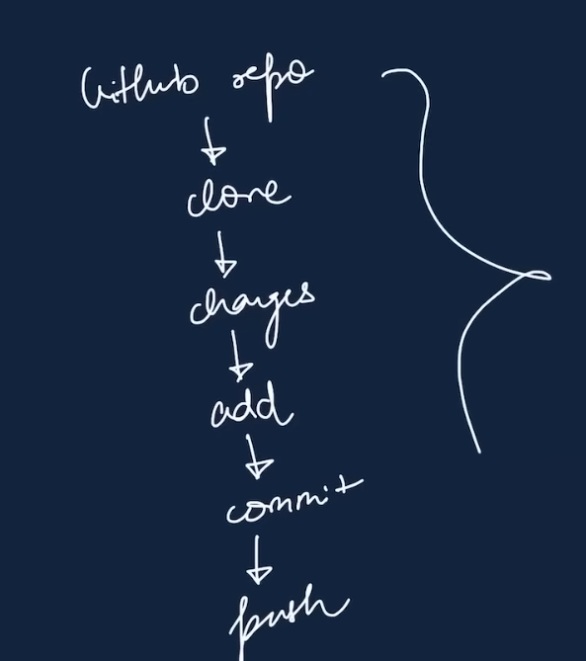

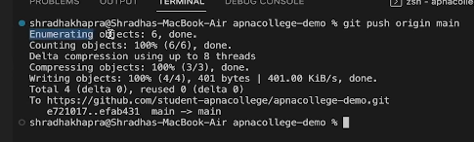
Means successful push

Git push origin main
Origin -> means that repo where we get the clone link
Main -> branch

Mtlb k hmra jo repo h usp directly push krwana chteh
Hmre pass 2 condition hote h project ko manage krne k lye

- Remote project ko access krte h phr usme changing krte h using local repo then return push krdete hn remote
- Local repo p km start krte hn then use remote repo bna kr usp push krte hn

Repo -> local
Local -> Github

So for option 2 we have

Init cmd
Init -> used to create a new git repo (new git repo ki shurwat)

Git init
Git remote add origin link
Git remote -v
Git branch
Git branch -M main
Git push origin main

Go to outside directory write
Cd ..
Mkdir localrepo -> make new directory
Go to inside directory write
Cd localrepo

Ls -a
Git init
Ls -a

Git push -u origin main
For long term change so we use -u
Then just enter git push

First setup on github then local -. Prefer because it will be easy

Work flow
- Github repo
- Clone
- Changes
- Add
- Commit
- Push

Git branches

Ek project p multiple features p km horha hota h tu us k lye multiple branches bnatae h
Don’t wait make copy & start work

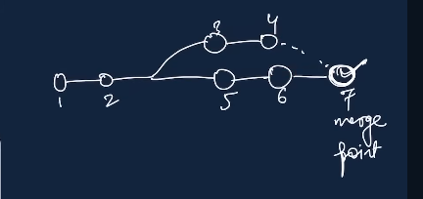

Work on multiple copies then add to the original copy

Branch cmd
Git branch -> to check branch
Git branch -M main -> to rename branch
Git checkout branch name -> to navigate
Git checkout -b new branch name -> to create new branch
Git branch -d branch name -> to delete branch

If you want to delete branch so first you have to move to the other branch then you will be able to delete that branch

Git push origin branchname

Merging code
Way 1
Git diff branch name -> to compare commits, branches, files & more
Git merge branch name -> to merge 2 branches

Way 2
Create a PR (pull request)

Pull cmd
Pull request -> means that it lets you tell others about changes you have pushed to a branch in a repo on github.

First pull req review then merge

Pull req k alag se commit hota h ye bh ek change h

Pull cmd
Git pull origin main

Remote change ko local p lanae k lye

Git log -> or check all commits

